Image Orientation Detection

Tao Chen, Ruijing Bao
Department of Electrical and Computer Engineering
Texas A&M
College Station, TX 77840

Abstract—In this project, we will present an application for detecting an image orientation, using VGG16 networks based on CNN algorithm to extract features, and fix the orientation accordingly.
Keywords—image orientation, VGG16, Guided Grad-Cam, Guided Backpropagation

Introduction

Nowadays, digital cameras have come very common in our life. Every phone, laptop or tablet is equipped with one. Digital images are more common and easily produced than ever. One can take a photo in any place and time. After uploading the images to the PC, We notice that some of the images are rotated, and need to go through your album manually preform the fixes. The process is a time consuming and therefore nobody is doing so and the album staying as is unfixed.
In this project, we discuss the problem of rotating an image to its correct orientation. Initially, we have a preprocessed image rotated by 0°, 90°, 180° or 270°. Then we train a deep convolutional neural network (CNN) to detect the correct orientation of the image. The training dataset comes from Indoor CVPR. Also, we apply Guided Grad-Cam and Guided Backpropagation to make the neural network visible and explain how the CNN makes the correction.

CNN Algorithm && VGG-16

CNN algorithm to image orientation detection
For image orientation detection, some software tools have the capability to straighten them, provided that the image is already in the right orientation. To illustrate that, let’s take a look at the Level tool of Adobe Photoshop Lightroom. As you can see in the images below, this kind of tool can correct small rotations with high accuracy (look at the edge of the road as a reference for the horizon.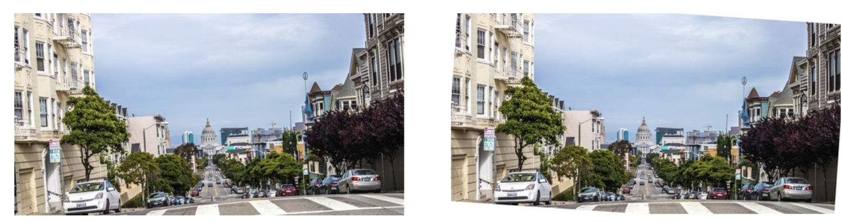
Figure 1:Left: Original image. Right: Image corrected with Lightroom's Level tool.

However, it is very limit to a very specific image dataset because the features of the images are variable and hard to classify them. For example, in the previous case, we would easily figure out that the image is upside down by acknowledging the position of the sky and the road. But in another case like a person, it is not the case.
Hence, it’s where CNN comes in. Convolutional neural networks (CNNs) are good at processing data that can be spatially arranged (2D or 3D). Typical use cases of CNNs are object detection and recognition. And based on the CNN algorithm, it will be very easy to get the features of all possible scenarios.
CNNs are organized into interconnected layers of artificial neurons. The first layer’s input is connected to the raw data that we want to process (images, text, etc.) and the last layer output is whatever we want to predict.
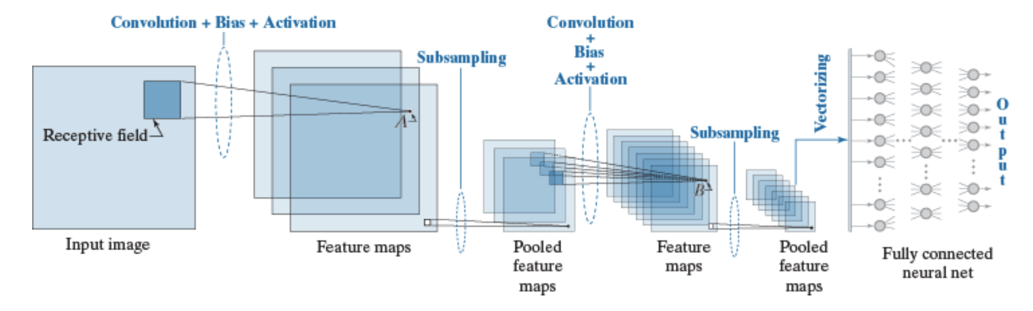
Figure 2: CNN Architecture

The purpose of the transformations that take place at each layer is to compute features. In machine learning, features are attributes that simplify the representation of the data. While traditional feature extraction methods are manually implemented by humans, the CNN algorithm can extract the optimal feature by itself. And in general, when the networks are trained with more data, it will learn higher level features based on the dataset.
Therefore the networks will learn its own features to make the best decision. The only thing we need to do is feeding the labelled data to the networks. When we feed the data, the networks will train these data and update the weights of every layer continuously. In other words, as the training progresses, the weights are updated to produce better features which help the network make better predictions.
More specifically, there are three most important layers in the CNN.
Fully-connected layer: this is the simplest type of layer. It connects all its inputs to all the outputs of the preceding layer. It is usually used for making decision.
Convolutional layer: this is the type of layer that performs most of the computation in a convolutional neural network, hence their name. In essence, convolutional layers operate in a similar way to fully-connected layers. The difference is that the neurons are small kernels only connected to a small portion of the inputs, as opposed to all of them. These kernels are small two-dimensional windows that are slid over all the spatial locations in an image in order to compute a specific feature.
Pooling layer: this type of layer downsample its input. Similar to convolutional layers, pooling layers consist of small sliding kernels that simply average spatial regions (average pooling) or take the maximum value (max pooling). Downsampling is typically used in convolutional neural networks to reduce the number of weights in consecutive layers, which in turn reduces their computational complexity.
What is more important is that unlike to Convolution layers, the pooling layers usually extract the main features of the all features that extracted by the Convolution layer hence reduce the computation.
And there are some abstract introduction of the CNN architecture and the main idea of the algorithm.

VGG16 NET
Last paragraph we introduce the main content of the CNN algorithm. And nowadays, the common technique for building a CNN classiﬁer for a new domain is to adopt an architecture originally designed for the ImageNet dataset modify it, apply it to the new domain which used the conception of Transfer learning.
Then we found that VGG16 Net is a great architecture for our dataset to transfer since it is very expandable and generalizable to other image dataset . And the way to use the transfer learning is that we keep the main parameters of the VGG16 model and just replace the 1, 000 outputs corresponding to the 1, 000 objects with 4 outputs corresponding to 0◦, 90◦, 180◦, or 270◦. And the parameters mean that the weights of the whole networks. The only layer we need to train with is the fully-connected layer. This indicates that we are doing some transfer learning: VGG-16 detects 1000 classes of objects, which would be useful for detecting orientation. Likely initializing our weights to those of VGG-16 makes our network converge to nearby values of the weights.
Then we introduce the VGG16 network briefly. VGGNet is developed by Oxford university and Google which is a deep convolution neural network. It construct the simple architecture by repeatedly add the 3*3 convolution kernels and 2*2 pooling layers over the whole neural networks. It is the structure of the VGGNet.
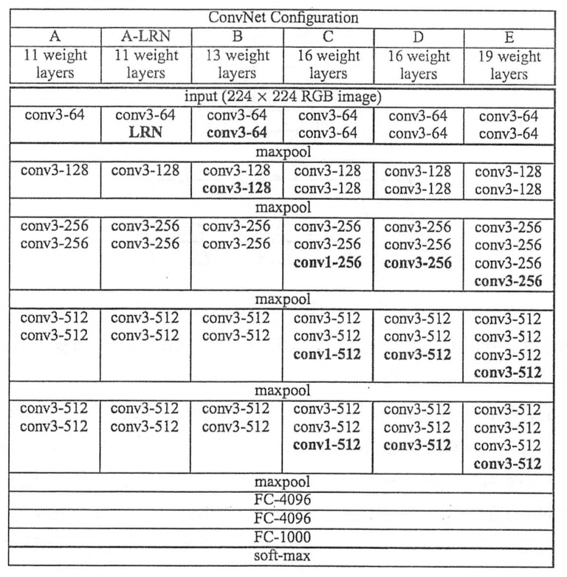
Figure 3: VGGNet Structure
We can know that the VGGNet has three convolution layers in a block of one convolution and in every convolution it will have a max pooling layer to reduce the complexity of the features. And in the VGGNet, there are many 3*3 convolution layers connected which is very useful in parameter reduction.
Hence, likely initializing our weights to those of VGG-16 makes our network converge to nearby values of the weights. The set of photos is transformed by rotating all the photos in the original training set by 0 ◦ , 90 ◦ , 180 ◦ , or 270 ◦ . The VGG architecture requires that the input be of size 224 × 224 × 3. We resize the input image to ﬁt inside a 224 × 224 square, and pad it as necessary with black pixels in order for the input to be 224 × 224.

Guided Backpropagation
Basically, we get the conception of the CNN algorithm and the VGGNet model. However, we still don’t know why it should be right and trustworthy because the neural network is a black box progress hence we don’t truly know what happened exactly.
Therefore we use a variant of Guided Backpropagation to visualize the most important feature for the machine to recognize the image. Guided Backpropagation computes a modiﬁed version of the gradient of a particular neuron with respect to the input. It is the reverse convolution progress, which is based on the conception of the backpropagation which means that differential the input.
The idea of the guided propagation is that neurons act like detectors of particular image features. Because we only care about the features that the neuron detects so we can set that all the negative gradients to 0 since we only back propagate the gradients that the input and the gradient are all lager than 0 which is the mean of Guided.
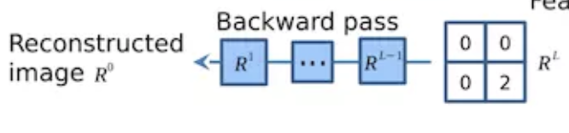
Figure 4: set to zero all activations except one

Guided backpropagation is a way of visualizing which pixels provide evidence for the presence of features in the input image that inﬂuence the output neuron. The pixels that are visualized never depress features causing the neuron of interest to activate. Instead, they only activate features throughout the layers of the network. However, because of the reason, there is also a problem exists. All the features that it extract will be shown when the gradient is larger than 0. Hence, we cannot figure out exactly which feature decide the result just like the figure 5.
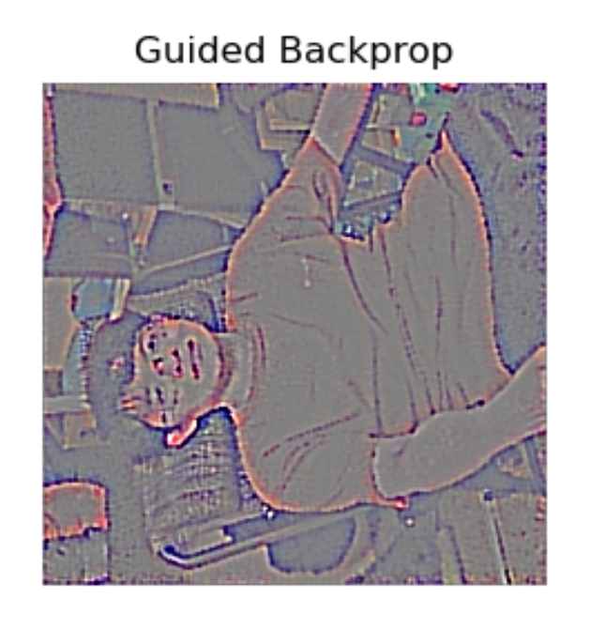
Figure 5: Guided Backpropagation

Although we can see that the intensity of the image is different, can we found a way to make it clearer?

Grad Cam
In the last paragraph, we discuss a way to make the feature visualize. Here we implement a way to make the decided feature clearer which is named Grad Cam.
It is very similar to the Guided Backpropagation algorithm back propagating the gradients of every layer’s input and deconvolution the network to get every feature.
However, the Grad Cam algorithm gets every feature’s weight and then sum up the weighted sum. And it use the global average of the gradients to calculate the weights. If we define the k^{th} feature map’s weight is \alpha_k^c
Where Z is the number of pixels in k^{th} feature map, y^c is the value of input before the softmax layer, A_{ij}^k is the pixel value of the point (i,j) in k^{th} feature map.
And it is the structure of the Grad Cam in figure 6.
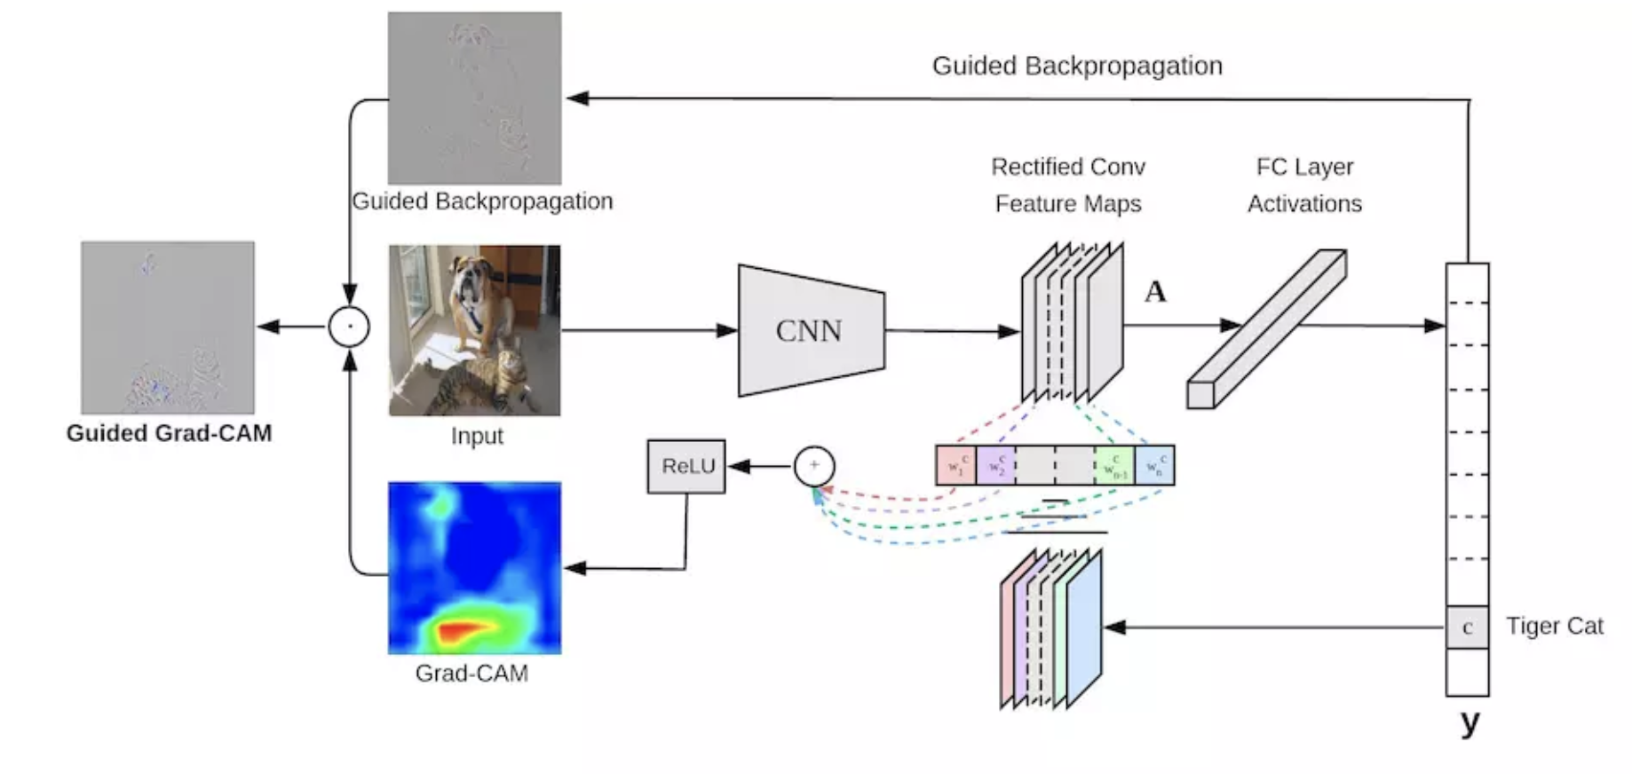
Figure 6:Grad Cam Structure

And we add a Relu function to the weighted sum shown in Figure7. because we only care the pixels that have positive influence to the classification. If not, it may bring in some pixels that are not included in this classification.
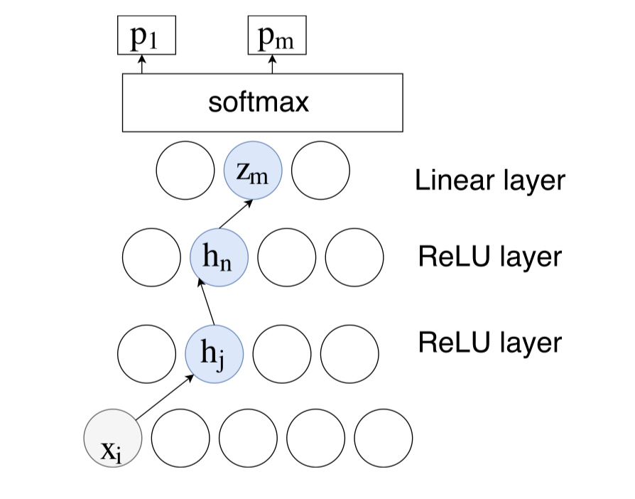
Figure 7: Relu function in the Grad Cam

Hence, we solve the problem exists in the Guided Backpropagation which is that the Guided Backpropagation are not so sensitive to the feature.

Exeperimental Results

Dataset Description
Most scene recognition models have good performance in outdoor scenes but poor in indoor scenes. The Indoor CVPR Dataset contains 67 indoor categories and 15620 images. The scenes provided by this dataset are full of both local and global discriminative information, which means more details of scenes will be contained in the dataset. For our project, the substantial details are helpful to detect the orientation of images. By testing different categories of images, we believe that

Experimental Results
Before we implementing the VGG16 model, we randomly choose the images in Indoor CVPR dataset, and rotate the original images by 0°, 90°, 180° and 270° respectively. The purpose for preprocessing the images is to create a new dataset with various rotated angles, so that we can implement the VGG16 to detect the correct orientation.
We classify the preprocessed image into 4 groups (i.e. 0°, 90°, 180° or 270°), and calculate their accuracy separately. Since the preprocessed image has been put into four folders named by their rotated angles respectively, we compare the corrected angle obtained by VGG16 with the angle shown by the folder name. The accuracy rates are shown in Table 1.
Rotated Angle | 0° | 90° | 180° | 270°
Accuracy | 93.8% | 92.9% | 91.8% | 92.4%
Table 1. Orientation detection accuracy for different rotated angles
As we can see from the table, the accuracy for all rotated angles is above 90%. And the VGG model have the highest accuracy to detect correct angles if we do not rotate the angles of images, as we expected. However, the model has the lowest accuracy to detect correct angles of images rotated by 180°. No matter which group the rotated images belongs to, the accuracy rate is satisfying.

Some Common Mistakes
- The word “data” is plural, not singular.
- The subscript for the permeability of vacuum μ₀, and other common scientific constants, is zero with subscript formatting, not a lowercase letter “o”.
- In American English, commas, semicolons, periods, question and exclamation marks are located within quotation marks only when a complete thought or name is cited, such as a title or full quotation. When quotation marks are used, instead of a bold or italic typeface, to highlight a word or phrase, punctuation should appear outside of the quotation marks. A parenthetical phrase or statement at the end of a sentence is punctuated outside of the closing parenthesis (like this). (A parenthetical sentence is punctuated within the parentheses.)
- A graph within a graph is an “inset”, not an “insert”. The word alternatively is preferred to the word “alternately” (unless you really mean something that alternates).
- Do not use the word “essentially” to mean “approximately” or “effectively”.
- In your paper title, if the words “that uses” can accurately replace the word “using”, capitalize the “u”; if not, keep using lower-cased.
- Be aware of the different meanings of the homophones “affect” and “effect”, “complement” and “compliment”, “discreet” and “discrete”, “principal” and “principle”.
- Do not confuse “imply” and “infer”.
- The prefix “non” is not a word; it should be joined to the word it modifies, usually without a hyphen.
- There is no period after the “et” in the Latin abbreviation “et al.”.
- The abbreviation “i.e.” means “that is”, and the abbreviation “e.g.” means “for example”.
An excellent style manual for science writers is [7].

Using the Template
After the text edit has been completed, the paper is ready for the template. Duplicate the template file by using the Save As command, and use the naming convention prescribed by your conference for the name of your paper. In this newly created file, highlight all of the contents and import your prepared text file. You are now ready to style your paper; use the scroll down window on the left of the MS Word Formatting toolbar.

Authors and Affiliations
The template is designed for, but not limited to, six authors. A minimum of one author is required for all conference articles. Author names should be listed starting from left to right and then moving down to the next line. This is the author sequence that will be used in future citations and by indexing services. Names should not be listed in columns nor group by affiliation. Please keep your affiliations as succinct as possible (for example, do not differentiate among departments of the same organization).

For papers with more than six authors: Add author names horizontally, moving to a third row if needed for more than 8 authors.

For papers with less than six authors: To change the default, adjust the template as follows.

Selection: Highlight all author and affiliation lines.

Change number of columns: Select the Columns icon from the MS Word Standard toolbar and then select the correct number of columns from the selection palette.

Deletion: Delete the author and affiliation lines for the extra authors.

Identify the Headings
Headings, or heads, are organizational devices that guide the reader through your paper. There are two types: component heads and text heads.
Component heads identify the different components of your paper and are not topically subordinate to each other. Examples include Acknowledgments and References and, for these, the correct style to use is “Heading 5”. Use “figure caption” for your Figure captions, and “table head” for your table title. Run-in heads, such as “Abstract”, will require you to apply a style (in this case, italic) in addition to the style provided by the drop down menu to differentiate the head from the text.
Text heads organize the topics on a relational, hierarchical basis. For example, the paper title is the primary text head because all subsequent material relates and elaborates on this one topic. If there are two or more sub-topics, the next level head (uppercase Roman numerals) should be used and, conversely, if there are not at least two sub-topics, then no subheads should be introduced. Styles named “Heading 1”, “Heading 2”, “Heading 3”, and “Heading 4” are prescribed.

Figures and Tables

Positioning Figures and Tables: Place figures and tables at the top and bottom of columns. Avoid placing them in the middle of columns. Large figures and tables may span across both columns. Figure captions should be below the figures; table heads should appear above the tables. Insert figures and tables after they are cited in the text. Use the abbreviation “Fig. 1”, even at the beginning of a sentence.
- Table Type Styles
Table Head | Table Column Head
Table Head | Table column subhead | Subhead | Subhead
copy | More table copyª
- Sample of a Table footnote. (Table footnote)
- Example of a figure caption. (figure caption)
Figure Labels: Use 8 point Times New Roman for Figure labels. Use words rather than symbols or abbreviations when writing Figure axis labels to avoid confusing the reader. As an example, write the quantity “Magnetization”, or “Magnetization, M”, not just “M”. If including units in the label, present them within parentheses. Do not label axes only with units. In the example, write “Magnetization (A/m)” or “Magnetization {A[m(1)]}”, not just “A/m”. Do not label axes with a ratio of quantities and units. For example, write “Temperature (K)”, not “Temperature/K”.

Acknowledgment (Heading 5)
The preferred spelling of the word “acknowledgment” in America is without an “e” after the “g”. Avoid the stilted expression “one of us (R. B. G.) thanks ...”. Instead, try “R. B. G. thanks...”. Put sponsor acknowledgments in the unnumbered footnote on the first page.

References
The template will number citations consecutively within brackets [1]. The sentence punctuation follows the bracket [2]. Refer simply to the reference number, as in [3]—do not use “Ref. [3]” or “reference [3]” except at the beginning of a sentence: “Reference [3] was the first ...”
Number footnotes separately in superscripts. Place the actual footnote at the bottom of the column in which it was cited. Do not put footnotes in the abstract or reference list. Use letters for table footnotes.
Unless there are six authors or more give all authors’ names; do not use “et al.”. Papers that have not been published, even if they have been submitted for publication, should be cited as “unpublished” [4]. Papers that have been accepted for publication should be cited as “in press” [5]. Capitalize only the first word in a paper title, except for proper nouns and element symbols.
For papers published in translation journals, please give the English citation first, followed by the original foreign-language citation [6].

- G. Eason, B. Noble, and I. N. Sneddon, “On certain integrals of Lipschitz-Hankel type involving products of Bessel functions,” Phil. Trans. Roy. Soc. London, vol. A247, pp. 529–551, April 1955. (references)
- J. Clerk Maxwell, A Treatise on Electricity and Magnetism, 3rd ed., vol. 2. Oxford: Clarendon, 1892, pp.68–73.
- I. S. Jacobs and C. P. Bean, “Fine particles, thin films and exchange anisotropy,” in Magnetism, vol. III, G. T. Rado and H. Suhl, Eds. New York: Academic, 1963, pp. 271–350.
- K. Elissa, “Title of paper if known,” unpublished.
- R. Nicole, “Title of paper with only first word capitalized,” J. Name Stand. Abbrev., in press.
- Y. Yorozu, M. Hirano, K. Oka, and Y. Tagawa, “Electron spectroscopy studies on magneto-optical media and plastic substrate interface,” IEEE Transl. J. Magn. Japan, vol. 2, pp. 740–741, August 1987 [Digests 9th Annual Conf. Magnetics Japan, p. 301, 1982].
- M. Young, The Technical Writer’s Handbook. Mill Valley, CA: University Science, 1989.

IEEE conference templates contain guidance text for composing and formatting conference papers. Please ensure that all template text is removed from your conference paper prior to submission to the conference. Failure to remove template text from your paper may result in your paper not being published.

We suggest that you use a text box to insert a graphic (which is ideally a 300 dpi TIFF or EPS file, with all fonts embedded) because, in an MSW document, this method is somewhat more stable than directly inserting a picture.
To have non-visible rules on your frame, use the MSWord “Format” pull-down menu, select Text Box > Colors and Lines to choose No Fill and No Line.

